Experiment no -6:
Code:-
#include <stdio.h>
#include <string.h>

int main()
{
char s[100];
int i, n, flag = 1;

printf("Enter a string: ");
scanf("%s", s);

n = strlen(s);

if (n % 2 != 0)
flag = 0;
else
{
for (i = 0; i < n / 2; i++)
{
if (s[i] != '0' || s[n - 1 - i] != '1')
{
flag = 0;
break;
}
}
}

if (flag)
printf("String belongs to CFG");
else
printf("String does not belong to CFG");

return 0;
}
Output:-
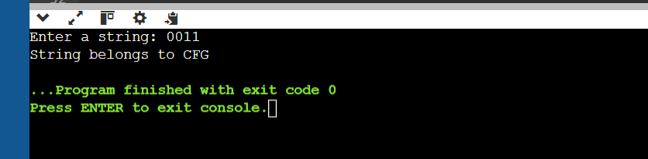
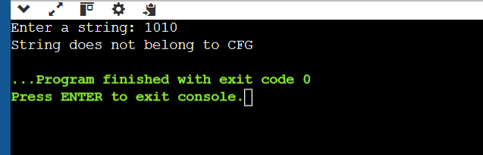
Experiment no – 7:-
Code :-
#include <stdio.h>
#include <string.h>

int main()
{
char s[100];
int i, count = 0;

printf("Enter a string: ");
scanf("%s", s);

for (i = 0; s[i] != '\0'; i++)
{
if (s[i] == '1' && s[i+1] == '0' && s[i+2] == '1')
count++;
}

if (count == 1)
printf("String belongs to CFG");
else
printf("String does not belong to CFG");

return 0;
}
Output:-
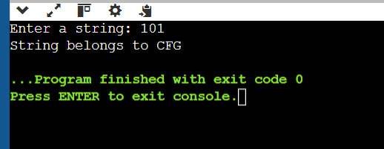
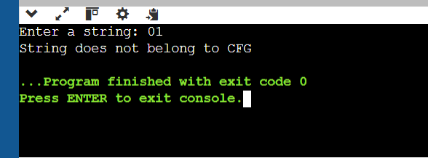
Experiment no 8:-
Code:-
#include <stdio.h>
#include <string.h>

int main()
{
char s[100];
int n;

printf("Enter a string: ");
scanf("%s", s);

n = strlen(s);

if (n >= 2 && s[0] == 'b' && s[n-1] == 'a')
printf("String Accepted");
else
printf("String Rejected");

return 0;
}
Output:-
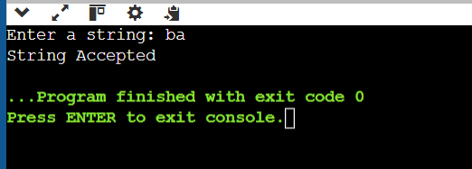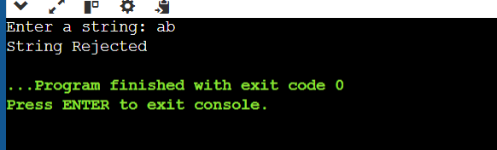
Experiment no 9:-
#include <stdio.h>
#include <string.h>

int main()
{
char s[100];
int n;

printf("Enter a string: ");
scanf("%s", s);

n = strlen(s);

if (n >= 2 && s[0] == '0' && s[n-1] == '1')
printf("String Accepted");
else
printf("String Rejected");

return 0;
}

Output:-
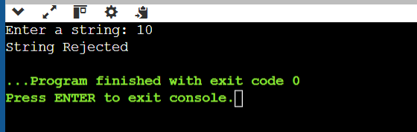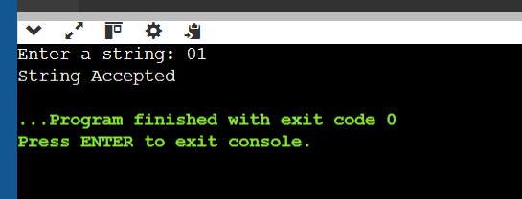
Experiment no - 10
Code:-
#include <stdio.h>

int main()
{
int n, e, i, j, a, b;
int mat[10][10] = {0};

printf("Enter number of states: ");
scanf("%d", &n);

printf("Enter number of epsilon transitions: ");
scanf("%d", &e);

printf("Enter transitions (from to):\n");

for (i = 0; i < e; i++)
{
scanf("%d%d", &a, &b);
mat[a][b] = 1;
}

for (i = 0; i < n; i++)
{
int closure[10] = {0};
closure[i] = 1;

for (j = 0; j < n; j++)
{
if (closure[j])
{
for (int k = 0; k < n; k++)
{
if (mat[j][k])
closure[k] = 1;
}
}
}

printf("Epsilon closure of q%d = { ", i);

for (j = 0; j < n; j++)
{
if (closure[j])
printf("q%d ", j);
}

printf("}\n");
}

return 0;
}
Output:-


